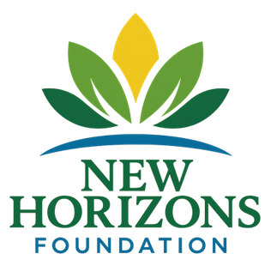
DONATION INSTRUCTIONS PAGE
New Horizons Foundation
Federal 501(c)(3) Public Charity
Check Donations
Please make checks payable to:
New Horizons Foundation
Mail to: New Horizons Mental Health Foundation HQ
Arizona Programming Office – Phoenix Metro
4817 Medical Center Dr Suit 3A
McKinney, TX 75069
Memo Line: 2026 Early-Intervention Initiative

ACH / Wire Transfer
Bank Name: JP Morgan Chase Bank NP
Account Name: New Horizons Mental Health Foundation
Routing Number: 021000021
Account Number: 2907530887
Account Type: Business Checking
(ACH authorization form available upon request.)
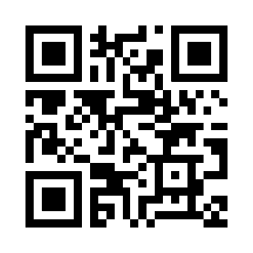
Online Donations
Secure online donations available at:
www.TheNewHorizonsFoundation.org/donate

Tax Information
Legal Name: New Horizons Mental Health Foundation Inc.
EIN: 41-3658405
IRS Determination Letter Available Upon Request
All donations are tax-deductible to the extent permitted by law.

